Emanon College Lab Build

Project Background
Emanon College’s strategic direction is to promote itself as a top-tier, state-of-the-art business and technical college. There has been a significant shift in the need to use computer systems, even in non-technical subject areas. There are currently only five computer labs on campus, with a total of 100 workstations that are all more than five years old. These labs are all used 14 hours per day; some classes have two students per system, and the intent in the Fall term is to increase course offerings that will require extensive use of computer lab facilities.

Need/Requirement
The college does not have sufficient computer lab space to handle the increased demand, and the systems in the labs are rapidly becoming obsolete. A feasibility study was conducted to determine the computer lab needs of the college in more measurable terms. The result of this study was a recommendation to undertake a project to double the number of computer labs and computers in the college, and update all of the lab equipment to current technology.

Objectives
The objective of this project is to build ten computer labs at Emanon College to increase the lab capacity by 100% and equip the labs with technology that is no less than one year old before Fall classes start this year.

Project Scope

Deliverables

Deliverable 1: Project Documentation

Description:
Project administration documentation includes the project plan, project reports, quality control and assurance documents, change control documents, project closing documents, and other project information.

Specifications:

Project plan
The project plan is a comprehensive, integrated, detailed set of files, including the following components:
- Project Summary Plan
  - The Summary Plan integrates all of the detailed project plan information into a single document. This document is used to communicate the project plan to a variety of stakeholders, and it is used as a single document to obtain formal project plan approval.
- Project Scope Statement
- The project scope statement must define all necessary deliverables with objectively measurable acceptance criteria.
- Work Breakdown Structure
- The WBS must contain all tasks required to complete the deliverables and meet the objectives of the project broken down to activities of no less than:
    - 24 hours of effort,
    - 3 days duration, or
    - 0.5% of the total project budget; and no more than
    - 2.5% of the total project budget unless it is a fixed cost.
- Resource Assignments
- All activities must have resource assignments sufficient to complete the work within the schedule constraints.
- Network Diagram
- The network diagram must identify the critical activities and the total and free slack on every activity.
- Project Schedule
- The schedule must identify the start and finish dates for all activities with all resources leveled to a day-by-day level, and it must meet all constraints identified by the stakeholders. The project schedule must also identify significant milestones on the project, which are evenly distributed throughout the duration of the project.
- Project Budget
- The project budget must include a detailed task expense statement, a detailed resource expense statement, and a cash flow projection for the entire project duration.
- Risk Register
- The risk register must include:
    - a risk listing identifying risk events with their triggers and symptoms;
    - a qualitative analysis of the identified risks on the project;
    - risk responses for all risks; and
    - risk resource responsibility assignments.
- Communication Plan
- The communications plan must define standards, processes, policies, and responsibilities for creation, distribution and storage of project information.
- Management Plans (as deemed necessary by the project manager)
- Any additional management plans will be broadly-framed or highly-detailed, formal or informal as defined by the project manager during planning.

Project Reports
Project reports are created periodically, and at specific times throughout the project. Project reports will be produced in accordance with the project Communications Plan.

Quality documents
Quality control and quality assurance documents will be in accordance with the processes and policies defined the college’s ISO procedures.

Closing documents
Project closing documents will include: all project information, project acceptance forms, project transition documents, including final “as-built” documents, a final project report detailing all of the comparative information between baseline and actual values on the project, final financial statements, and a lessons learned document with lesson, background, benefit, implementation plan, and responsibility.

Acceptance Criteria:
For project documentation to be acceptable, all specifications must be met.

Deliverable 2: Lab Design Documents

Description

The design documents are comprehensive room drawings and specifications for all computer labs. They must include detailed, scaled information on all labs, including all furniture, equipment, and hardware to be in each room, furniture specifications, equipment specifications including software, layout/floor plan of the room, and construction specifications.

Specifications

Lab Rooms
The following rooms have been designated as new computer labs for this project:

Building – Borlaug Biology Building
Rooms – B107, B108

Building – Marquez Library
Rooms – L315, L316*

Building – Salam Science Center
Rooms – S324, S325, S326

Building – Sen Economics Building
Rooms – E210, E211, E212

Each room must have all design documentation. Room L316 in Marquez Hall has been designated as being a “Mac Lab,” in which all computers are Apple Macintosh computers. A total of 200 student workstations, plus instructional workstations and peripheral equipment must be divided between the rooms to meet the objective.

Requirements Breakdown Diagrams
Each lab will have a requirements breakdown diagram that defines the specific requirements of the lab and the hierarchical relationships between the requirements. Specifically, requirements will include no less than the following categories:
- Layout
- Technology
- Furniture
- Aesthetics
- Architecture

The requirements diagrams will be similar to the following, but will be more detailed and specific to each new computer lab:

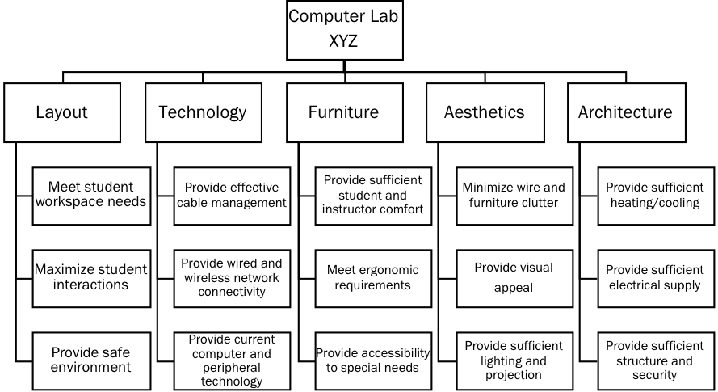

Furniture Specifications
Each lab will have a set of furniture specifications, which define the following information:
- Student workstation/desk specifications
  - Type
- Number of desks
- Dimensions (shape, length, width, height, space requirement)
- Construction (materials)
- Instructor workstation/desk specifications
- Type
- Number of desks
- Dimensions (shape, length, width, height, space requirement)
- Construction (materials)
- Chair specifications
- Type
- Number of chairs
- Dimensions
- Construction (materials)
- Table specifications
- Type
- Number of tables
- Dimensions (shape, length, width, height, space requirement)
- Construction (materials)
- Whiteboard specifications
- Type
- Number of whiteboards
- Dimensions
- Construction (materials)

Equipment Specifications
Each lab will have a set of equipment specifications, which define the following information:
- Computer specifications
- Chassis dimensions, weight, colour, bays, slots, ports
- Power supply
- Storage devices
- Processors
- Operating Systems
- Software configuration
- Chipset
- Memory
- Graphics
- Graphics Processing Unit
- Hard drives
- Hard drive controller
- Network controller
- Audio controller
- Security
- Regulatory & Environmental Compliance
- Warranty Service Level Requirements
- Monitor specifications
- Size (inches)
- Type (flat panel)
- Resolution
- Connection type (VGA, DVI, other)
- Projector specifications
- Projection brightness, contrast ratio, resolution, uniformity, projection lens, image size, distance
- Lamp
- Audio
- Security
- Connectivity
- Video compatibility
- Keystone correction
- Colour, size & weight
- Electrical specifications
- Environmental temperatures (operating, storage, shipping)
- Mounting requirements (mount type, support structure, etc.)
- Accessories
- Projection screen specifications
- Number
- Type
- Diagonal size
- Image width
- Image height
- Screen surface type
- Aspect ratio
- Gain
- Viewing angle
- Features (fixed, manual pull-down, electric, other, etc.)
- Dimensions (width, depth, height, weight)
- Mounting requirements
- Peripheral specifications
- Type of peripheral (keyboard, mouse, mouse pad, printers, scanners, etc.)
- Dimensions
- Connection type
- Relevant information based on industry standards (e.g. size, connection, type, etc.)

Room Layout Drawings/Renderings
Each lab will have a set of room layout drawings and renderings, which define the following information:
- room dimensions including walls, entrances, windows, ceilings, and angles.
- equipment dimensions and placement including:
- computers
- monitors
- keyboards
- mice and pads
- printers
- projectors
- screens
- scanners
- other peripheral equipment as necessary
- furniture dimensions and placement including:
- student workstations/desks
- instructor workstation/desk
- chairs
- whiteboards
- other furniture as necessary

All layout drawings will include a 3D rendering of the room, and 2D technical drawings in AutoCAD format. The 3D rendering will enable virtual review of the room design. Room layouts must address the requirements defined for each room in its Requirements Tree document. Primarily, all room layouts must meet the college seating density requirements for minimum space per student of 2.5m². Consideration in layout must be given to creating an active learning environment and flexibility of use. The following picture provides an idea of the look of the final 2D technical drawings, but the specific drawings to be produced will be unique to each computer lab, its layout, furniture and equipment:
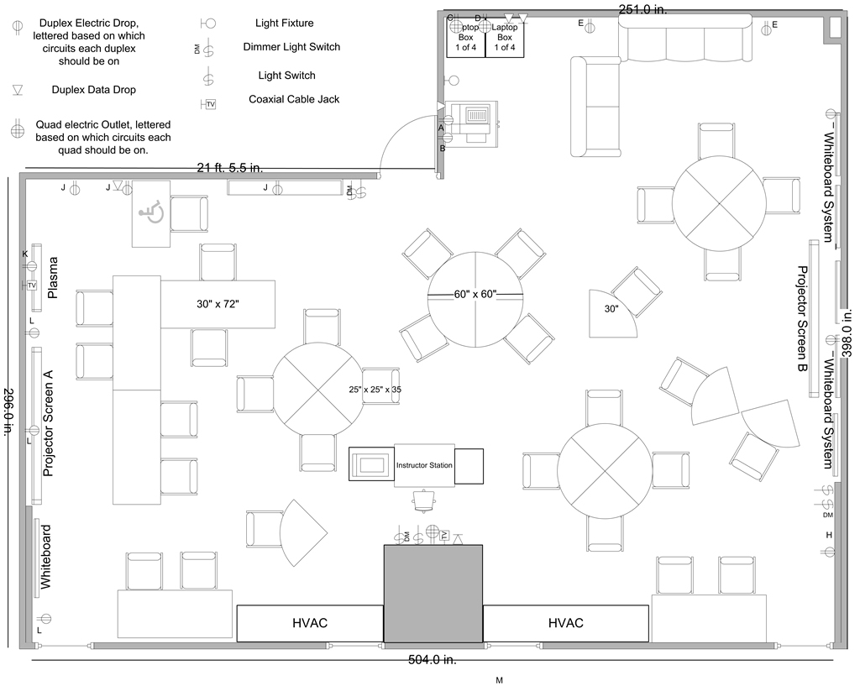

Construction Specifications/Drawings
Each lab will have a complete set of construction specifications and drawings, which define the following information:
- Electrical specifications
- Structural specifications
- Mechanical/HVAC specifications
- Communications/Network specifications
- Security specifications
- Environmental specifications
- Other specifications or drawings, as required, to build the computer labs.

Acceptance Criteria
For the design documents to be acceptable, all specifications must be met, and the following criteria must also be achieved:
- Each room will have its own package of design drawings, and files.
- All drawings will include the scale, drafter, designer, building, room number, symbols, and other key information to provide the user with exact information to be able to follow the drawing to build the facility.
- All construction specifications must meet generally accepted engineering standards as defined in the Project Resource Manual produced by the Construction Specifications Institute.

Deliverable 3: Ten Computer Labs

Description
The primary deliverable of this project is ten new computer labs. Each of these labs will include student workstations, at least one instructor workstation, and at least one digital projector and screen.

Specifications
The specifications for each lab will be defined in its associated design document package.

Lab Rooms
The following rooms have been designated as new computer labs for this project:

Building – Borlaug Biology Building
Rooms – B107, B108

Building – Marquez Library
Rooms – L315, L316*

Building – Salam Science Center
Rooms – S324, S325, S326

Building – Sen Economics Building
Rooms – E210, E211, E212

* Room L316 in the Marquez Library has been designated as a Mac Lab.

The following pictures provide an idea of the look of the final labs, but the specific design and look of each lab will be defined in more detail in its design documents:

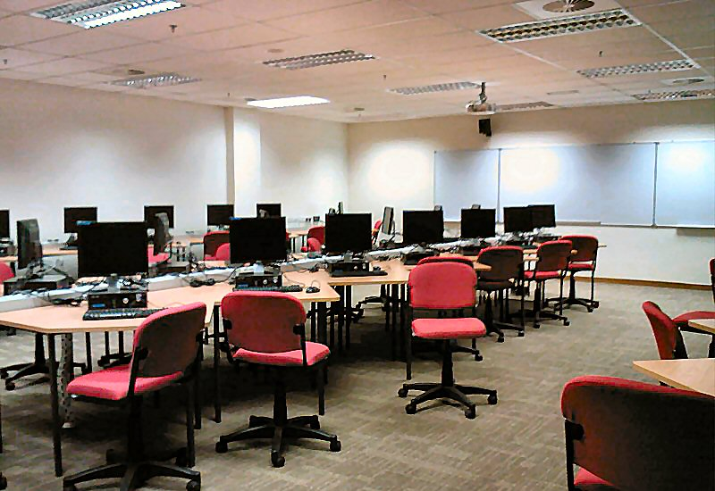

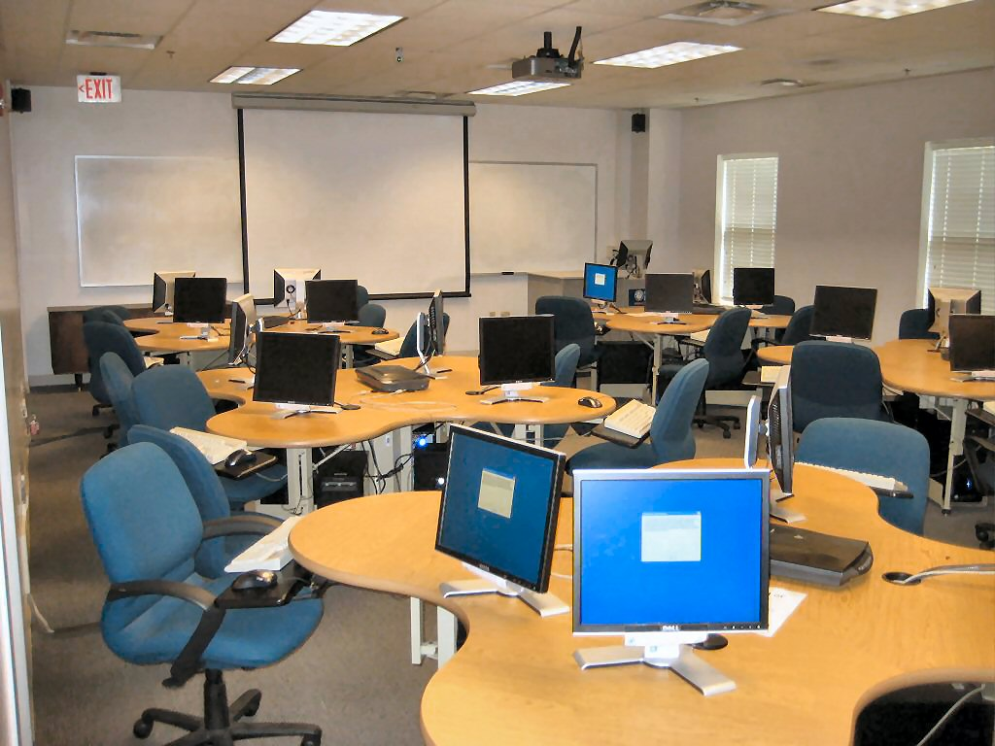

Acceptance Criteria
For each computer lab to be acceptable, all specifications in its design documents must be met.

Deliverable 4: Lab Maintenance Documents

Description
The lab maintenance documents are complete as-built documents and preventative and corrective maintenance procedures for all computer labs. They must include detailed drawings and specifications that reflect the actual facility conditions after completion.

Specifications
All drawings are to be in electronic format. Drawings are to be in .dwg format with all externally referenced files (X-REFs) to be combined (AutoCAD BIND) and saved into one file and textural documents in Microsoft Word (.docx), .rtf or indexed .pdf format and include AutoCAD .pc3 file (pen settings).

Architectural
- Dimensioned and labeled plans and elevations showing Walls, Doors, Windows and all fixed furniture, showing all variations incurred during construction.
- Site plan of new building location in relation to existing buildings and all general site works.
- Finishes schedule showing installed materials, type and colours.

Structural
- Clear and detailed documents identifying the final structural conditions, including all structural calculations.
- Static floor loadings are to appear for all spaces and in all areas where it differs.

Electrical
- Ceiling plans showing all lighting and power fittings and type
- All major cable sub-routes to sub-boards
- All major cable tray routes
- Distribution board numbers
- Circuit number, stud numbers
- Circuit sizes, 10A, 15A, 3 phase etc.
- All accessories, type of outlet, isolator, dedicated equipment outlet, etc.

Mechanical
- Dimensioned plant equipment and locations.
- All duct layouts, outlet positions and air quantities.
- All control locations and set points.
- Power circuiting and services schematics.

Communications & Data Network
- Cable routes, outlet types and location, and IP addresses.
- Wireless equipment installed, types, locations, IP addresses.

Security
- Identify areas of protection, device location, and type.
- Schematic control diagram.

Space
- Room number changes if any occurred (i.e. A room was divided).
- Designed floor loading.
- Designed space occupancy.

Operations and Maintenance Manuals
- Author and date of information
- Project description – names, number, etc.
- Project construction start and completion dates
- Consultant name(s), addresses and phone numbers
- Contractor name(s), addresses and phone numbers
- Schedule of all equipment installed
- Manual preparation date
- Building/site location
- Date of practical completion
- Construction handover dates
- Defects liability period
- Commissioning and deviation results
- Warranties and guaranties.

Acceptance Criteria
For the maintenance documents to be acceptable, all specifications must be met, and the following criteria must also be achieved:
- Each room will have its own package of maintenance documents.
- All construction specifications must meet generally accepted engineering standards as defined in the Project Resource Manual produced by the Construction Specifications Institute.
- Hard copy of all drawings and digital documents complying with requirements detailed above.
- A minimum of two (2) printed & bound sets of all maintenance manuals and one (1) set in digital form are provided.

Scope Exclusions
The following deliverables and tasks are excluded from the project:
Excluded from project: | Reason:
Developing and administering a college computer usage policy is out of scope for this project. | It is a function of the operations of the Information Systems (IS) Department
Software licensing is out of scope for this project. | The IS department procures enterprise licenses for most software, and faculty-specific software is managed through IS. Loading the software on the systems will be the responsibility of IS, yet it will be coordinated during installation of the computers in each lab.
Disposal of old furniture and equipment is out of scope for this project. | It is a function of the operations of the Facilities Department. The Facilities Department will remove old equipment and furniture from the existing labs, but the project team will be required to perform any demolition required for the project.
Promotion and communication of the new facilities is out of scope for this project. | It is the responsibility of the college administration.

Updated Detailed Assumptions
It is assumed that: | This will be validated by:
- the existing lab rooms have the electrical, cooling, and network capacity for the new lab equipment. | - conducting a site review during development of the design specifications for each lab.
- the existing labs already have security systems installed. | - conducting a site review during development of the design specifications for each lab.

Constraints
The following restrictions apply to the project:
Constraint imposed on project: | Reason:
The project must be completed no later than August 28 this year. | Because classes begin the following week in the labs.
The project must only use approved vendors in accordance with the college’s procurement policies and standards. | Because the college must comply with all government procurement and competition regulations.

Scope Management
Scope management is the process of managing of project deliverables and work to achieve the project objectives. The scope of this project is considered to be very stable because it is not likely to change, changes will not be frequent, and any changes should not be substantial.

Any changes to the deliverables or work require that an appropriate change control process be followed. Within the change control process, the change will be defined, assessed to determine the overall impact on the project, and a formal decision will be made whether or not the change should be incorporated into the existing project. If the change is deemed necessary, the Sponsor will be asked to approve the change. When the request has been approved, the appropriate adjustments will then be made to the project scope, schedule, budget, risks, and all other aspects of the baseline plan.

The following process will be used to manage scope and the scope revision requests:
- Any potential change that impacts the project’s scope, schedule, costs, or objectives will be documented with a Change Control Form.
- The project manager prepares the Change Control Form and documents the impacts the change will have.
- The project manager and Sponsor review the Change Control Form to decide if the request is appropriate and acceptable. The Sponsor has final authority to determine if the change should be approved and will assign additional funding or resources if required.
- Approved changes are grouped into a formal Contract Amendment if needed.
- Once accepted the project manager will revise the baseline project plan to reflect the accepted change. Any deliverable content that is expected to change will be documented in the Change Control Form. The contents of an approved Change Control Form (and any related documentation) will be an official amendment to the relevant sections of the Baseline Project Plan.

